**Azure Storage Services:**

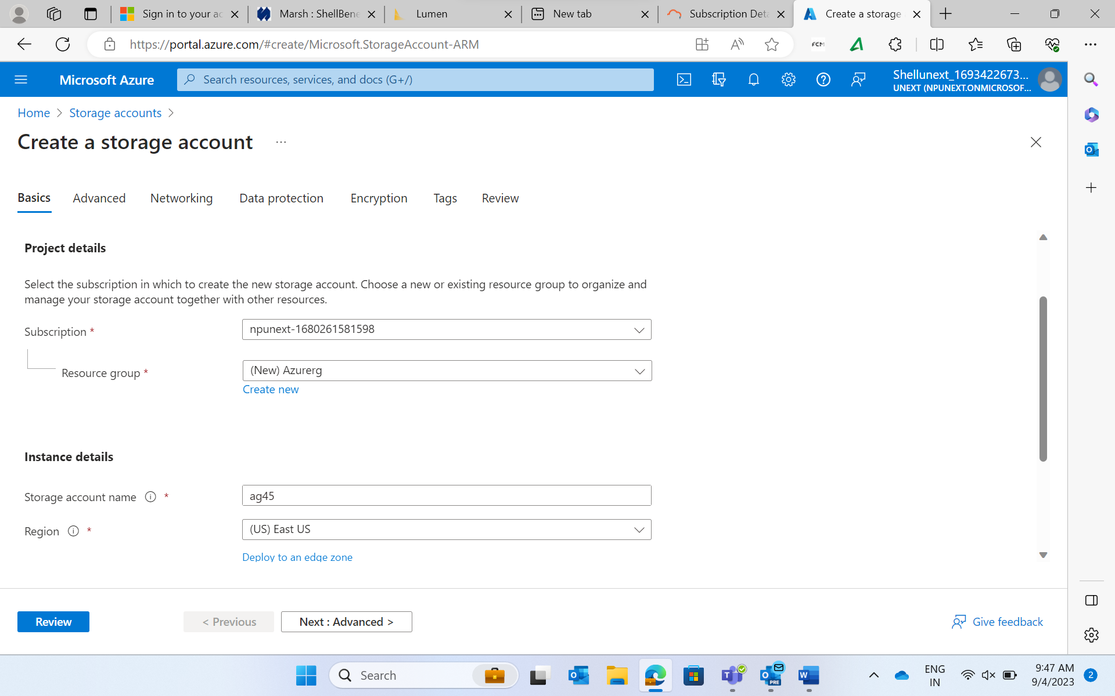

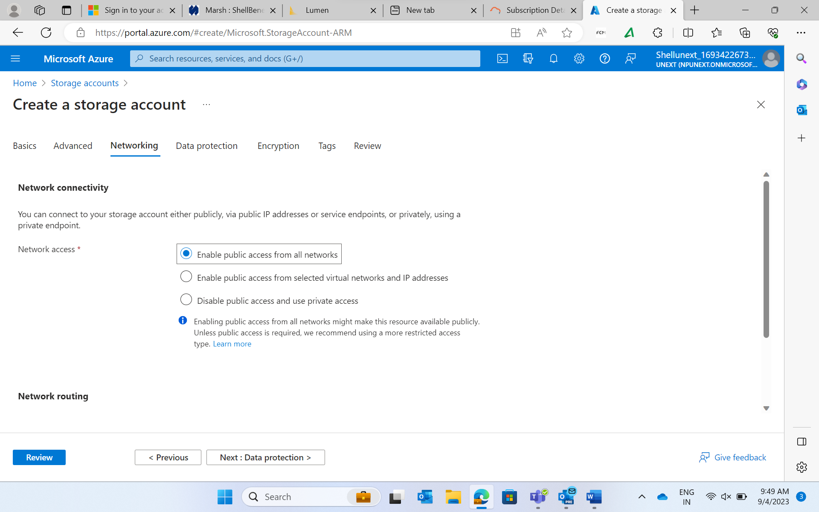

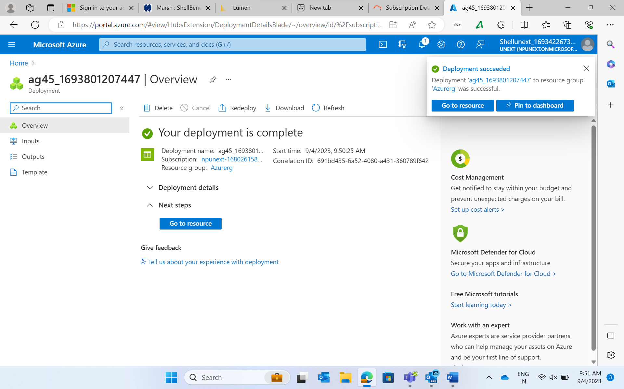

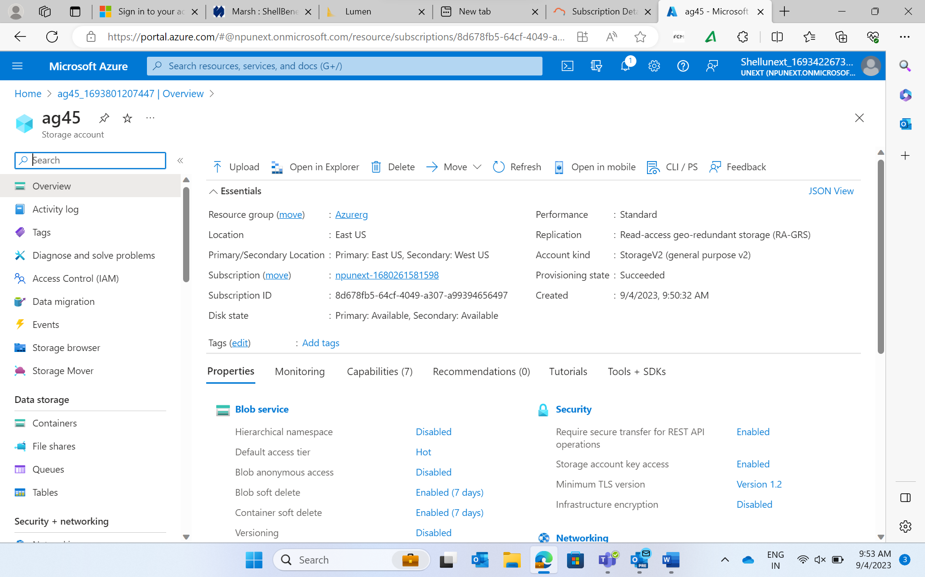

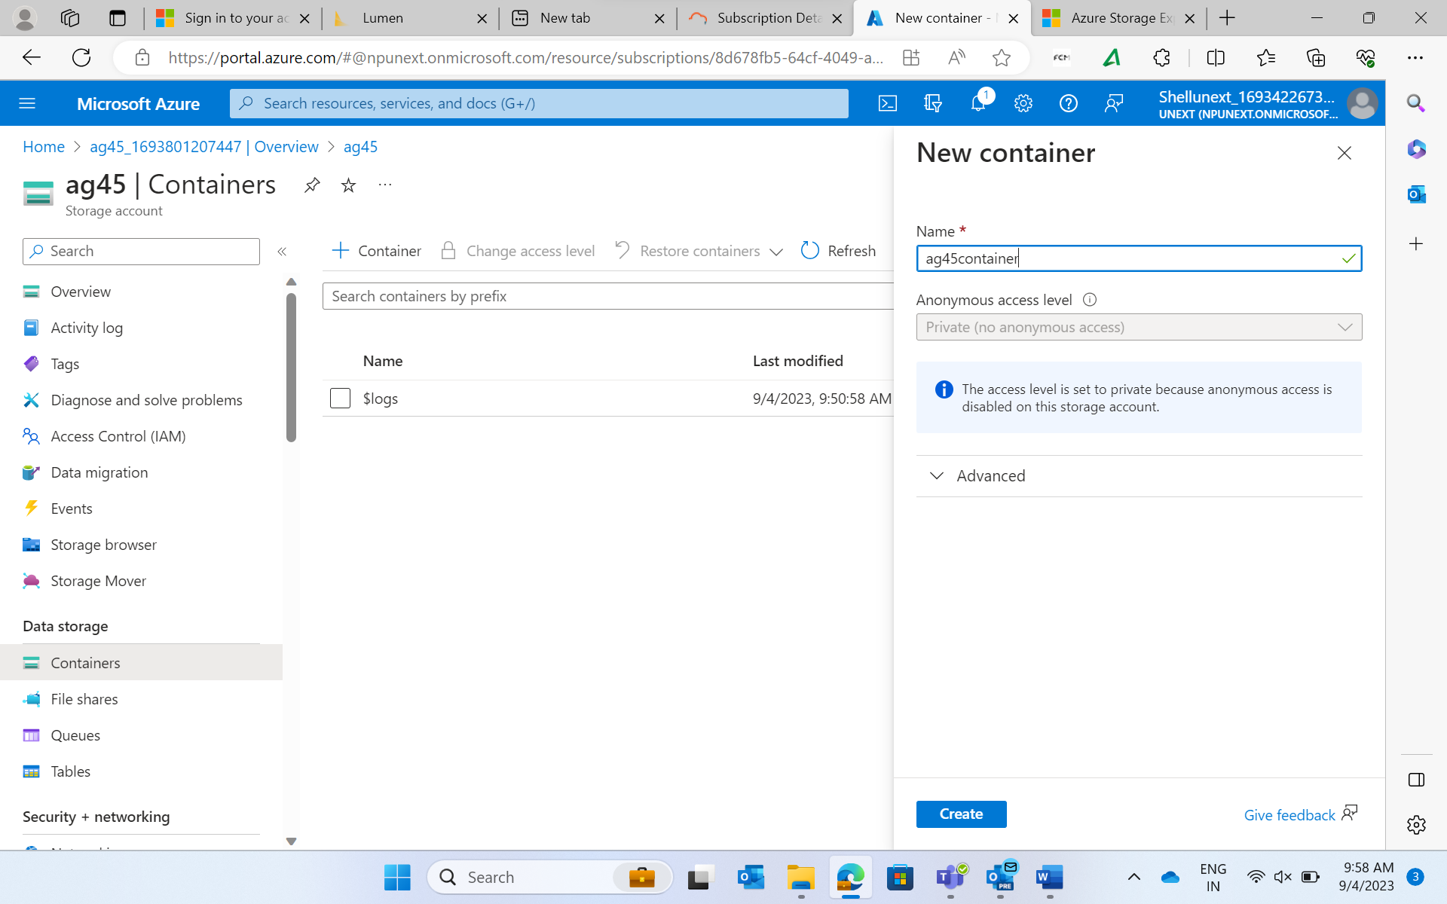

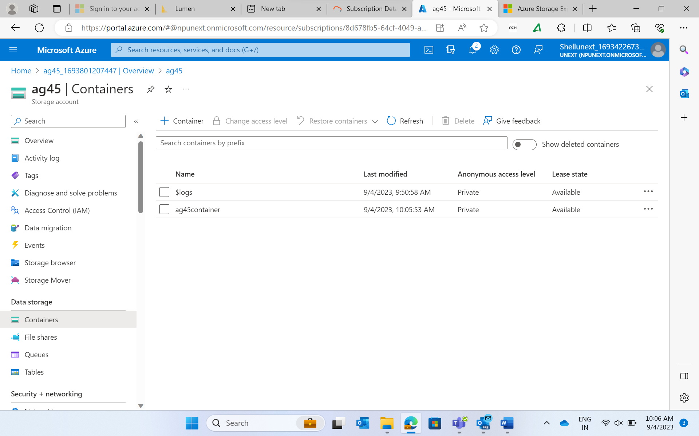

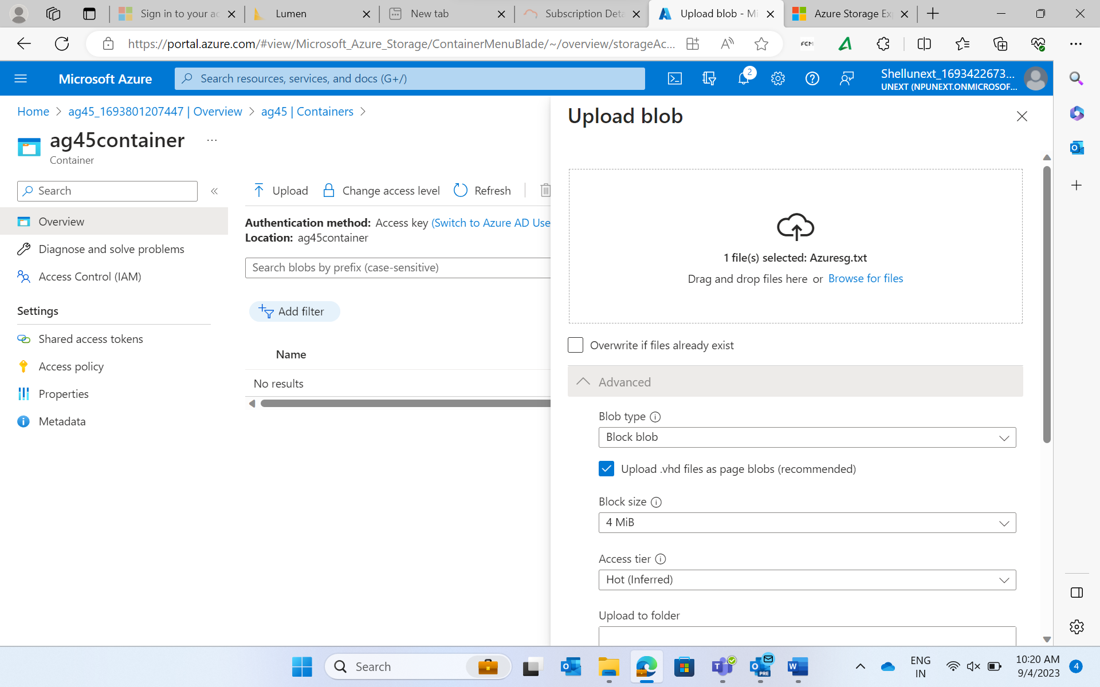

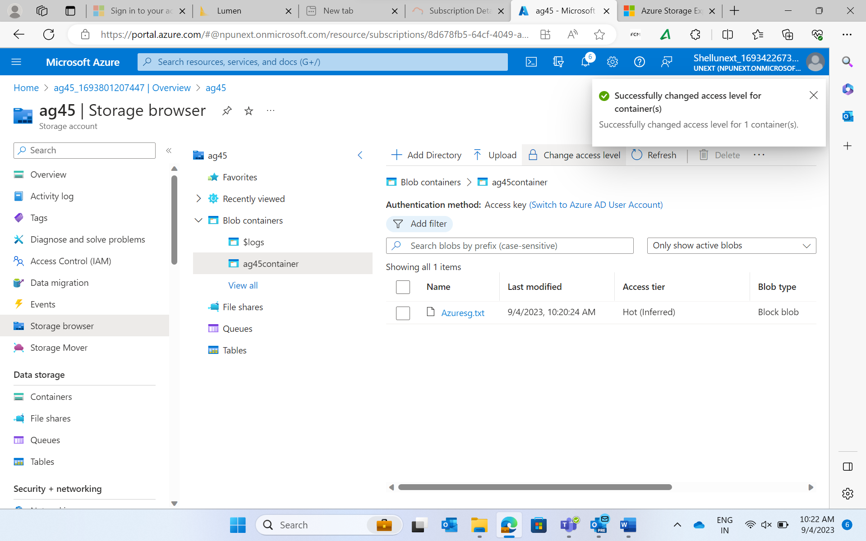

**Azure Storage:**

* Cloud based storage service.
* Provided by Microsoft as part of Microsoft Azure Cloud Platform

**File storage**: File storage, also called file-level or file-based storage, is exactly what you think it might be: Data is stored as a single piece of information inside a folder, just like you’d organize pieces of paper inside a manila folder. When you need to access that piece of data, your computer needs to know the path to find it.

**Block storage**

Block storage chops data into blocks and stores them as separate pieces. Each block of data is given a unique identifier, which allows a storage system to place the smaller pieces of data wherever is most convenient.

**Object storage:**

Object storage, also known as object-based storage, is a flat structure in which files are broken into pieces and spread out among hardware. In object storage, the data is broken into discrete units called objects and is kept in a single repository, instead of being kept as files in folders or as blocks on servers.

**Azure Storage access tiers include:**

* **Hot tier** - An online tier optimized for storing data that is accessed or modified frequently. The hot tier has the highest storage costs, but the lowest access costs.
* **Cool tier** - An online tier optimized for storing data that is infrequently accessed or modified. Data in the cool tier should be stored for a minimum of 30 days. The cool tier has lower storage costs and higher access costs compared to the hot tier.
* **Cold tier** - An online tier optimized for storing data that is infrequently accessed or modified. Data in the cold tier should be stored for a minimum of 90 days. The cold tier has lower storage costs and higher access costs compared to the cool tier.
* **Archive tier** - An offline tier optimized for storing data that is rarely accessed, and that has flexible latency requirements, on the order of hours. Data in the archive tier should be stored for a minimum of 180 days.

**Azure Queue Storage**

Azure Queue Storage is a service for storing large numbers of messages. You access messages from anywhere in the world via authenticated calls using HTTP or HTTPS. A queue message can be up to 64 KB in size. A queue may contain millions of messages, up to the total capacity limit of a storage account. Queues are commonly used to create a backlog of work to process asynchronously.

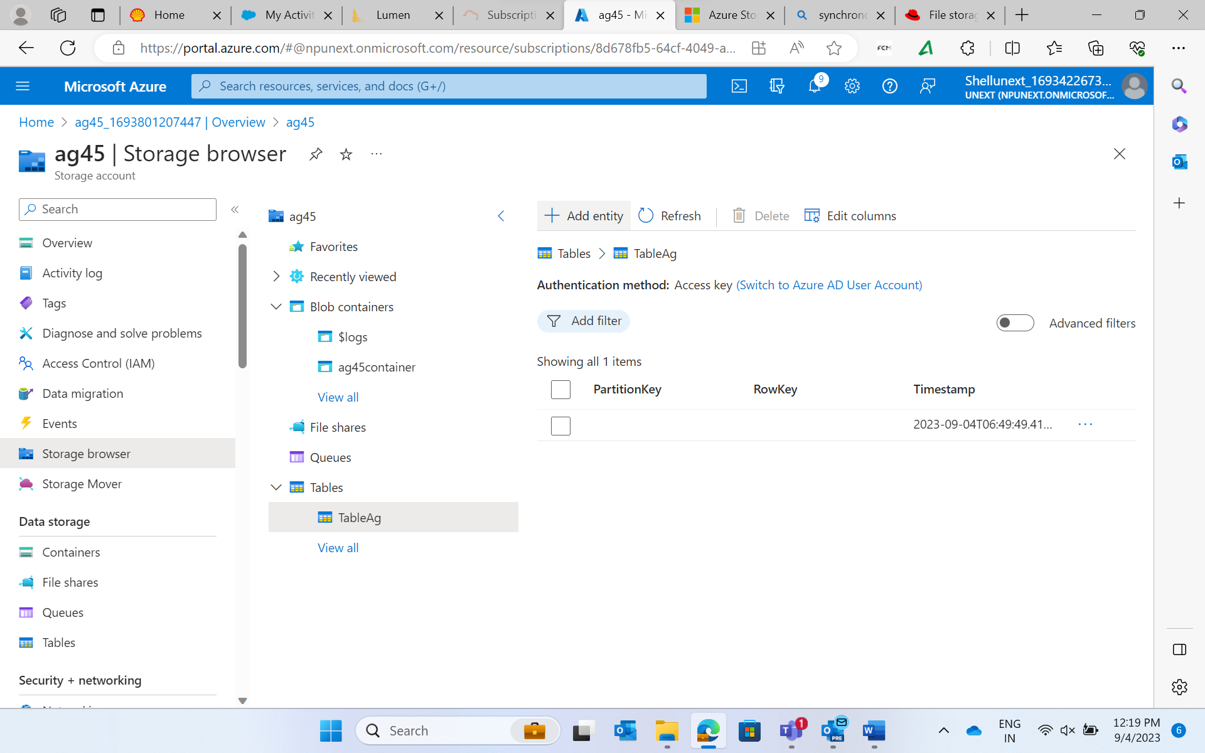

Azure Cosmos DB and Azure Storage are cloud-based storage services. They differ in terms of their data models, scalability, querying capabilities, and storage options. Here are the key differences between them:

**Data Model:** Azure Cosmos DB is a globally distributed, multi-model database service that supports various data models, including key-value, document, columnar, and graph. Azure Storage, on the other hand, primarily offers a simple object storage service with a key-value data model. It is designed for storing unstructured data such as blobs, files, queues, and tables.

**Scalability:** Azure Cosmos DB is built for global scalability and can automatically scale throughput and storage across multiple regions. It offers elastic scalability with fine-grained control over performance and cost. Azure Storage also provides scalability, but it requires manual configuration and management of storage accounts and blob containers to handle increased load. Scaling Azure Storage may involve sharding data across multiple storage accounts.

**Querying Capabilities:** Azure Cosmos DB supports rich query capabilities across various data models. It provides a SQL-like query language called SQL API for querying JSON documents. It also supports other APIs like Gremlin for graph data and MongoDB API for document-oriented querying. Azure Storage, on the other hand, does not offer built-in query capabilities. Retrieving data from Azure Storage typically involves directly accessing the stored objects using their unique keys.

**Storage Options:** Azure Cosmos DB provides storage for application data, along with built-in features like automatic indexing, data partitioning, and replication. It is a fully managed service that abstracts away the underlying storage implementation. Azure Storage, on the other hand, offers different types of storage options, including Blob storage for large object data, Queue storage for messaging, Table storage for structured NoSQL data, and File storage for file shares.

**Consistency Models:** Azure Cosmos DB offers multiple consistency models, allowing developers to choose the desired level of data consistency based on their application requirements. It provides options like strong consistency, bounded staleness, session consistency, and eventual consistency. Azure Storage, on the other hand, primarily provides eventual consistency for read operations. It may take some time for changes made to Azure Storage to propagate across different regions.

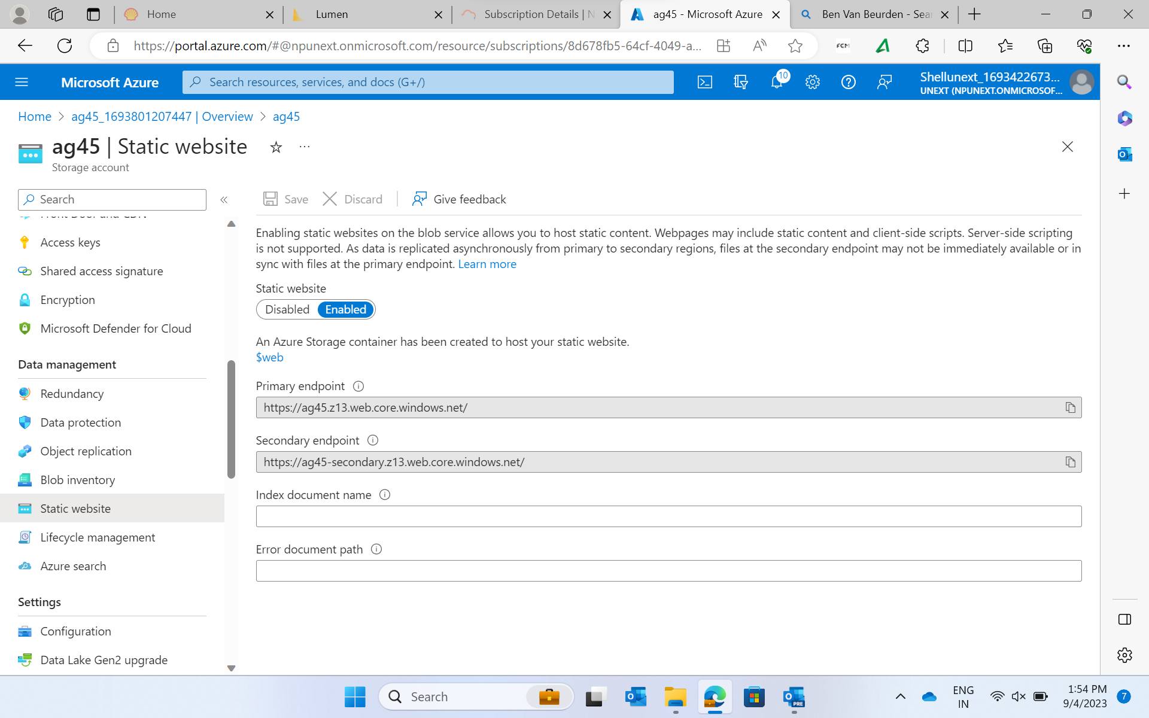

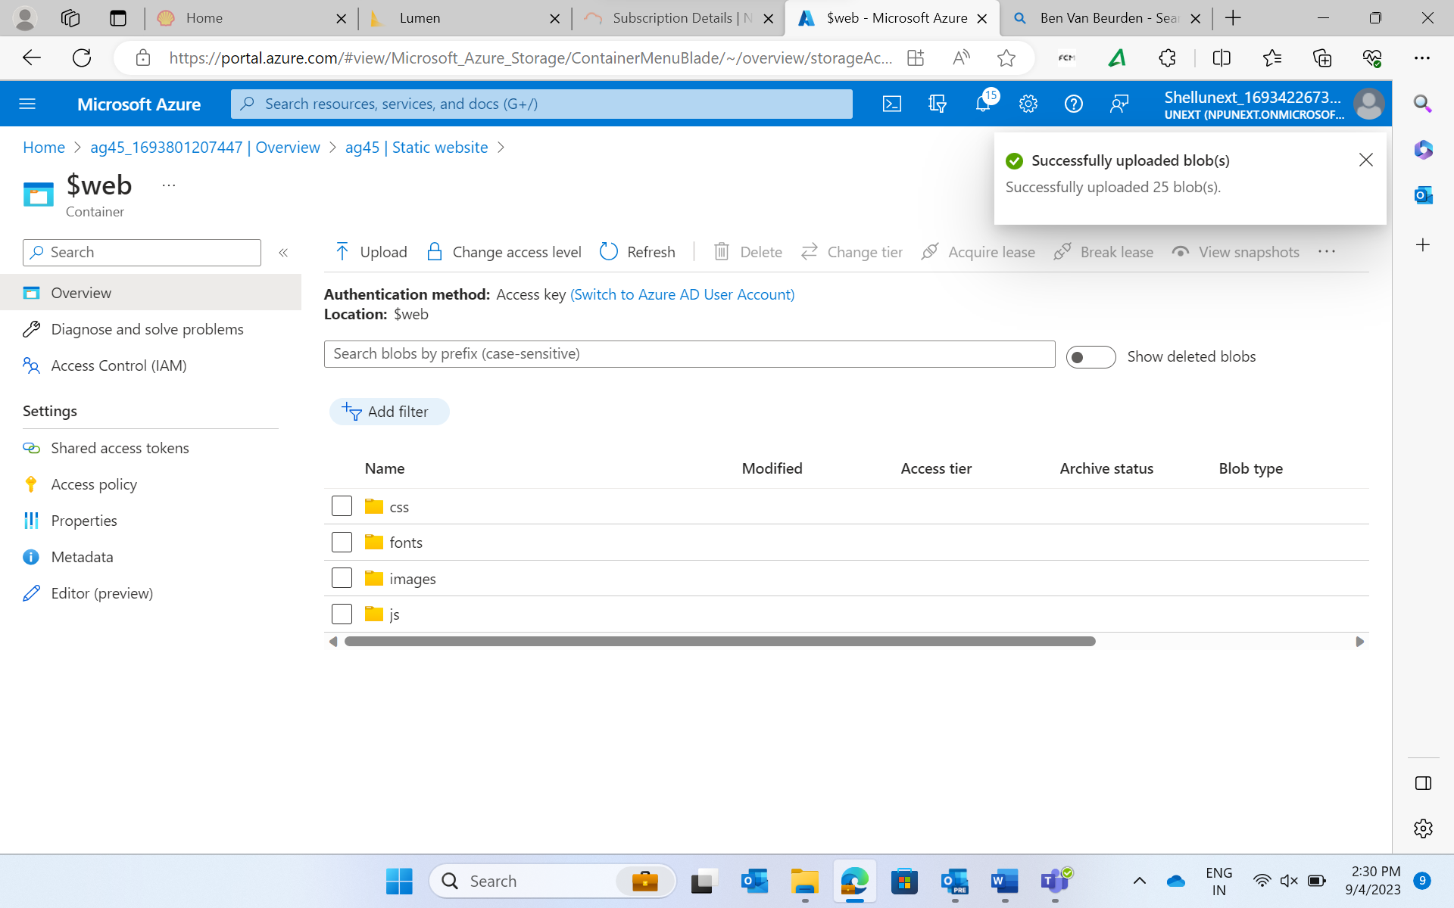

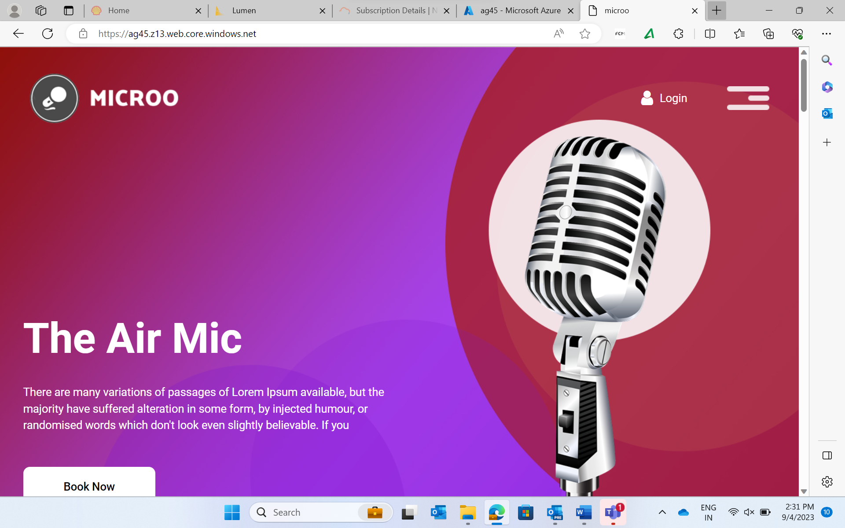

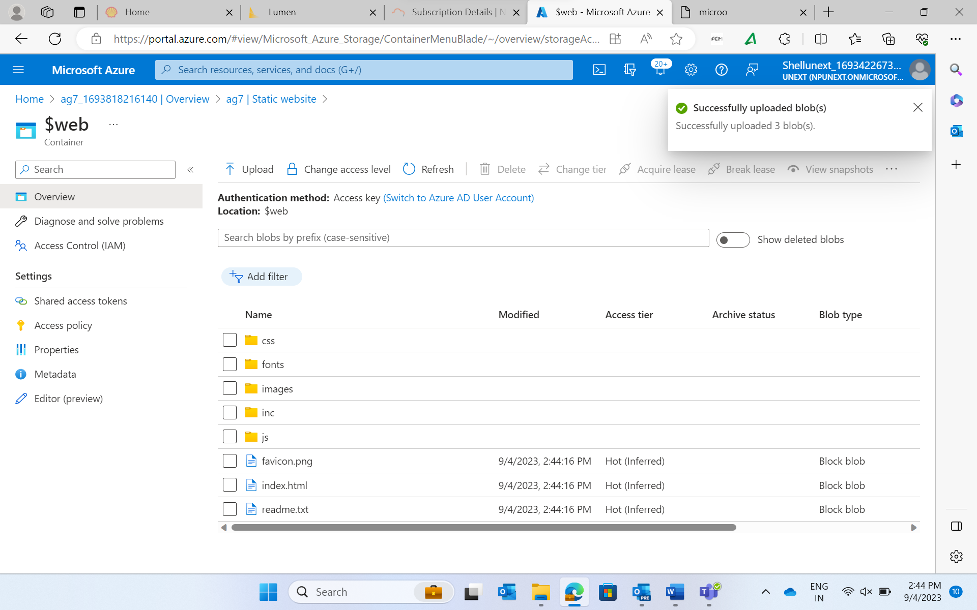



Azure Datalake Storage Gen2 or ADLSGen 2 and Azure Blob storage are both storage services offered by Microsoft Azure, but they